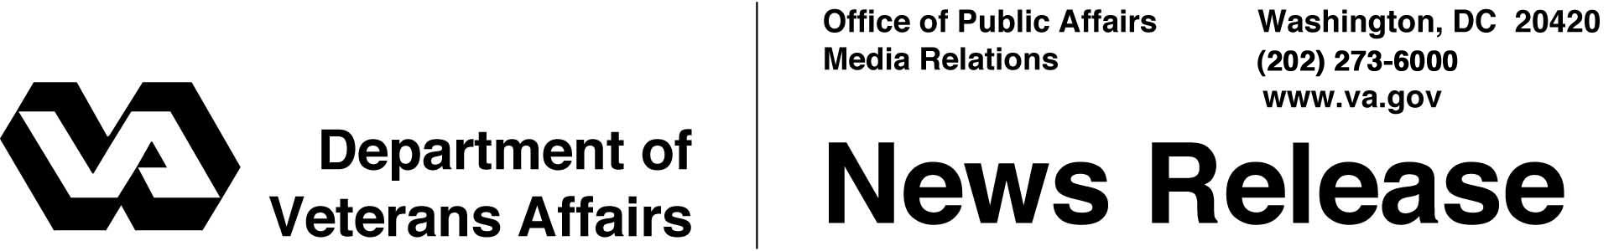

FOR IMMEDIATE RELEASE
October 13, 2005

VA Secretary Announces “Fulfilling the Commitment” Initiative
WASHINGTON – The Secretary of Veterans Affairs (VA) announced a new initiative called Fulfilling the Commitment – Coming Home to Work today at a three-day conference put on by VA to help veterans make the transition from military service to civilian life.
“All Americans can be grateful for the service and sacrifice of the men and women of our armed forces,” said the Honorable R. James Nicholson, Secretary of Veterans Affairs. "The VA is committed to assisting these young heroes in the transition from military life to the civilian work force through a wide-ranging array of programs."
"It just makes good common sense to hire these highly trained, disciplined young people, who volunteered, served and are now honorably discharged," he added.
Fulfilling the Commitment – Coming Home to Work is an umbrella initiative, a comprehensive intergovernmental and public-private alliance that will ensure separating Operation Iraqi Freedom (OIF) and Operation Enduring Freedom (OEF) veterans that they will have employment opportunities when they return home from the war on terrorism.
This initiative focuses on linking OIF/OEF service members to existing resources through local and regional job markets, regardless of where they separate, where they return, or the career or education they pursue.
The Bureau of Labor Statistics reports that in the first three quarters of 2005, almost 15 percent of veterans in the 20-24 year-old age group were unemployed, nearly three times the national rate.

- More -
Commitment 2/2/2

“The young men and women who protect our way of life need to know that they will have the opportunity to work and to take care of their families once they are discharged from military service,” said Nicholson.
Some 200,000 service members separate from active military service annually. This initiative will combine the efforts of federal, state and private sector entities to address their employment needs.
“This conference represents an important crossroads in our nation's history,” said R. Allen Pittman, VA’s Assistant Secretary for Human Resources and Administration. “The collective efforts of everyone at this conference will help us ensure that unemployment and under-employment are not barriers to the successful transition of service members from the battlefield back to mainstream America.”
VA is the nation's second-largest Cabinet department and one of the nation's largest employers of disabled veterans, with about 20,000 disabled employees among its work force of more than 237,000.

# # #
People wishing to receive e-mail from VA with the latest news releases and updated fact sheets can subscribe at the following Internet address:

http://www.va.gov/opa/pressrel/opalist_listserv.cfm

